Policy Statement
Retrofit Compliance Services Limited (the ‘Organisation’) aims to provide defect free and compliant products and services to its clients on time.
The Organisation operates a Quality Management System that has gained ISO 9001:2015 certification, including aspects specific to the design and coordination, and other related services of Retrofit installation projects.
The management is committed to:
- Develop and improve the Quality Management System
- Continually improve the effectiveness of the Quality Management System
- The enhancement of client satisfaction.
The management has a continuing commitment to:
- Ensure that client needs, and expectations are determined and fulfilled with the aim of achieving client satisfaction
- Communicate throughout the Organisation the importance of meeting client needs and all relevant statutory and regulatory requirements
- Establish the Quality Policy and to set Quality Objectives at relevant functions, levels and processes
- Ensure that the Management Reviews set and review the Quality Objectives, and report on the internal audit results as a means of monitoring and measuring the processes and the effectiveness of the Quality Management System
- Ensure the availability of resources.
The structure of the Quality Management System is defined in the organisation’s Quality Manual.
All personnel understand the requirements of this Quality Policy and abide with the contents of the Quality Manual. The Organisation complies with all relevant statutory and regulatory requirements. The Organisation constantly monitors its quality performance and implements improvements when appropriate.
This Quality Policy is regularly reviewed in order to ensure its continuing suitability.
Copies of the Quality Policy are made available to all members of staff and to relevant interested parties. Copies of the minutes of Management Reviews, or extracts thereof, are provided to individual members of staff in accordance with their role and responsibilities as a means of communicating the effectiveness of the Quality Management System.
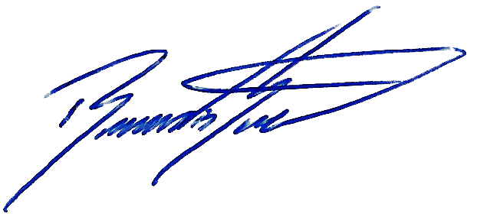

Signed:
Position: Managing Director
Date: 19/07/2025
Revision: 00

