Policy Statement
Retrofit Compliance Services Limited (the ‘Organisation’) remains aware of its responsibilities relating to OH&S matters throughout our business activities and as such are committed to preventing injury and ill health and to complying with all relevant health and safety legislation, regulations and other health and safety requirements.
We will regularly evaluate the hazards and risks from our activities, products and services and we will act to continually improve our health and safety performance by implementing an Occupational Health and Safety Management System that meets the requirements of ISO 45001:2018.
We will define health and safety objectives, targets and improvement actions that are related to this policy and to our significant health and safety risks. We will regularly evaluate progress against these through our ‘Management Review’ process thereby ensuring that our performance is subject to continual improvement.
We are committed to continuously providing relevant health & safety training and promoting health & safety awareness to employees and, where appropriate, to suppliers and to communicating our health & safety performance.
We will implement processes to prevent health & safety accidents, incidents, near misses and other nonconformities and to ensure that we are prepared to deal with potential health & safety emergencies.
We will investigate all possible site incidents to look at any remedial actions or lessons to be learnt to make all the areas in which we work to be as safe as practicable.
We will endeavour to consult with all our staff on matters relating to health and safety through regular meetings, toolbox talks and newsletters.
This OH&S Policy is maintained by regular review and is communicated to all the Organisation’s employees, suppliers, and sub-contractors.
This OH&S Policy is made available to all interested parties including members of the general public.
This OH&S Policy is subject to regular Management Review to ensure that it remains relevant and appropriate to the Organisation’s activities.
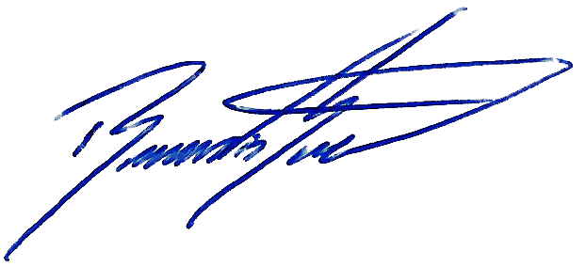

Signed:
Position: Managing Director
Date: 19/07/2025
Revision: 00

