Policy Statement
Retrofit Compliance Services Limited (the ‘Organisation’) recognises the importance of environmental protection and is committed to operating its business responsibly and in fulfilment of its compliance obligations relating to its scope of works. It is the Organisation’s declared policy to operate with and to maintain good relations with all regulatory bodies as specified under the organisation’s ISO 14001:2015 certification.
It is the Organisation’s objective to carry out all measures reasonably practicable to meet, exceed or develop all necessary or desirable requirements, to protect the environment and to continually improve the Environmental Management System to enhance environmental performance through the implementation of the following:
- Assess and regularly re-assess the environmental effects of the Organisation’s activities
- Training of employees in environmental issues
- Minimise the production of waste
- Minimise material wastage
- Minimise energy wastage
- Promote the use of recyclable and renewable materials
- Prevent pollution in all its forms
- Control noise emissions from operations
- Minimise the risk to the general public and employees from operations and activities undertaken by the Organisation.
Senior management demonstrates leadership and commitment with respect to the Environmental Management System by:
- Taking accountability for the effectiveness of the Environmental Management System
- Ensuring that the Environmental Policy and Environmental Objectives are established and are compatible with the strategic direction and the context of the Organisation
- Ensuring the integration of the Environmental Management System requirements into the Organisation’s business processes
- Ensuring that the resources needed for the Environmental Management System are available
- Communicating the importance of effective environmental management and of conforming to the environmental management system requirements
- Ensuring that the Environmental Management System achieves its intended outcomes
- Directing and supporting persons to contribute to the effectiveness of the environmental management system
- Promoting continual improvement
- Supporting other relevant management roles to demonstrate their leadership as it applies to their areas of responsibility.
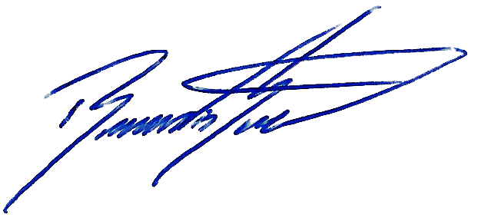
This Policy is communicated to all employees, suppliers, and sub-contractors and is made available to interested parties

Signed:
Position: Managing Director
Date: 19/07/2025
Revision: 00

