Policy Statement
Retrofit Compliance Services is committed to promoting equality of opportunity for all employees and job applicants as set out in the Equality Act 2010. We aim to create a working environment in which all individuals are able to make best use of their skills, free from discrimination or harassment, and in which all decisions are based on merit.
We do not discriminate against employees on the basis of age, disability, gender reassignment, marital or civil partner status, pregnancy or maternity, race, colour, nationality, ethnic or national origin, religion or belief, sex or sexual orientation ("protected characteristics").
The principles of non-discrimination and equality of opportunity also apply to the way in which employees treat visitors, clients, stakeholders and former employees.
All employees have a duty to act in accordance with this policy and treat their fellow colleagues with dignity at all times, and not to discriminate against or harass other employees, regardless of their status.
This policy does not form part of any employee's contract of employment and may be amended at any time. This policy covers all individuals working at all levels and grades (collectively referred to as employees in this policy).

Who is responsible for this policy?
The Managing Director has overall responsibility for the effective operation of this policy and for ensuring compliance with discrimination law.
Senior Management must set an appropriate standard of behaviour, lead by example and ensure that those they manage adhere to the policy and promote our aims and objectives with regard to equal opportunities.
If you have any questions about the content or application of this policy, you should contact: Brandon Smith – Managing Director.

Forms of discrimination
Discrimination by or against an employee is generally prohibited unless there is a specific legal exemption. Discrimination may be direct or indirect and it may occur intentionally or unintentionally.
Direct discrimination occurs where someone is treated less favourably because of one or more of the protected characteristics set out above. For example, rejecting an applicant on the grounds of their race because they would not "fit in" would be direct discrimination.
Indirect discrimination occurs where someone is disadvantaged by an unjustified provision, criterion or practice that also puts other people with the same protected characteristic at a particular disadvantage. For example, a requirement to work full time puts women at a particular disadvantage because they generally have greater childcare commitments than men. Such a requirement will need to be objectively justified.
Harassment related to any of the protected characteristics is prohibited. Harassment is unwanted conduct that has the purpose or effect of violating someone's dignity, or creating an intimidating, hostile, degrading, humiliating or offensive environment for them.
Victimisation is also prohibited. This is less favourable treatment of someone who has complained or given information about discrimination or harassment or supported someone else's complaint.

Recruitment and Selection
We aim to ensure that no job applicant suffers discrimination because of any of the protected characteristics above and individuals are treated on the basis of their relevant merits and abilities.
Job advertisements should avoid stereotyping or using wording that may discourage groups with a particular protected characteristic from applying.
Applicants should not be asked about health or disability before a job offer is made. There are limited exceptions, which should only be used with the Managing Director’s approval. For example:
- Questions necessary to establish if an applicant can perform an intrinsic part of the job (subject to any reasonable adjustments).
- Questions to establish if an applicant is fit to attend an assessment or any reasonable adjustments that may be needed at interview or assessment.
- Positive action to recruit disabled persons.
- Equal opportunities monitoring (which will not form part of the decision-making process).
Applicants should not be asked about past or current pregnancy or future intentions related to pregnancy. Applicants should not be asked about matters concerning age, race, religion or belief, sexual orientation, or gender reassignment without the approval of the Managing Director (who should first consider whether such matters are relevant and may lawfully be taken into account).
We are required by law to ensure that all employees are entitled to work in the UK. Assumptions about immigration status should not be made based on appearance or apparent nationality. All prospective employees, regardless of nationality, must be able to produce original documents (such as a passport) before employment starts, to satisfy current immigration legislation.

Termination of Employment
We will ensure that redundancy criteria and procedures are fair and objective and are not directly or indirectly discriminatory. We will also ensure that disciplinary action is applied without discrimination, whether it results in disciplinary warnings, dismissal or other action.

Disability Discrimination
If you are disabled or become disabled, we encourage you to tell us about your condition so that we can support you as appropriate.
If you experience difficulties at work because of your disability, you may wish to contact the Managing Director to discuss any reasonable adjustments that would help overcome or minimise the difficulty. Managing Director may wish to consult with you and your medical adviser(s) about possible adjustments. We will consider the matter carefully and try to accommodate your needs within reason. If we consider a particular adjustment would not be reasonable, we will explain our reasons and try to find an alternative solution where possible.

Training and Promotion
We monitor the conditions of service of all employees and their progression to ensure that they are being offered appropriate access to benefits and training and promotion opportunities.

Breaches of this Policy
If you believe that you may have been discriminated against you are encouraged to raise the matter with the Managing Director as a Grievance. If you believe that you may have been subject to harassment you are encouraged to raise the matter with the Managing Director.
Allegations regarding potential breaches of this policy will be treated in confidence and investigated thoroughly. Employees who make such allegations in good faith will not be victimised or treated less favourably as a result. False allegations which are found to have been made in bad faith will, however, be subject to disciplinary action.
Any employee who is found to have committed an act of discrimination or harassment will be subject to disciplinary action. Such behaviour may constitute gross misconduct and, as such, may result in summary dismissal. We take a strict approach to serious breaches of this policy.

Monitoring and Review of the Policy
We will continue to review the effectiveness of this policy to ensure it is achieving its objectives.
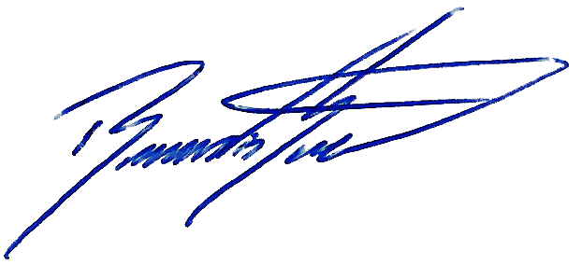

Signed:
Position: Managing Director
Date: 19/07/2025
Revision: 00

