Purposes
Retrofit Compliance Services’ Complaints procedure helps ensure that: -
- Client complaints are dealt with promptly, efficiently, courteously, and systematically.
- Client complaints are treated confidentially and fairly.
- Clients are kept informed of the progress and outcome of their complaints.

Procedures
To ensure we are able to put things rights as soon as we can, please read our complaints procedure below and we will respond promptly to ensure complete satisfaction. As soon as possible after the completion of the works, please inspect the work to ensure everything has been carried out to our usual high standards. In the unlikely event there is anything you are not completely satisfied with, please contact us about your complaint in the following ways:
In writing – send your queries to our head office (Crawford Suite, North East Business and Innovation Centre (BIC), Sunderland, Tyne and Wear, SR5 2TJ)
By telephone – call us on 0191 516 6388 during our office hours (Monday to Friday 9 AM – 5 PM)
By email – send your queries to info@retrofitcomplianceservices.co.uk
We aim to respond within 3 working days of receiving your complaint and where possible, will provide you with a date to remedy any issues raised.
We aim to resolve your complaint straightaway but if we are unable to do this, we will write to you within three business days with the following information:
- Why we have not resolved your complaint;
- Who is dealing with your complaint; and
- When we will contact you again.
We will aim to resolve your complaint quickly but it may take longer if it is complex.
We will keep you informed on a regular basis but if you need an update, please call us on 0191 516 6388 and ask to speak to the person handling your complaint.
There are 5 key stages in the procedure:
Stage 1 – Upon receipt of any client contact; via phone, e-mail, social media, letter, or verbal site communication, the contact is to be immediately recorded on the client database.
Stage 2 – Where the communication cannot be resolved immediately over the phone or on site, a member of the customer care team will then fully investigate the issue and contact the customer to arrange for any appropriate remedial action.
Stage 3 – In the event an issue cannot be dealt with by one of our team members, the issue will be escalated to the Head of Compliance and if necessary, a company director. This may necessitate a site visit to try to resolve the issue. The meeting is documented and records are kept on file for quality assurance records.
Stage 4 – In the unlikely event that the company senior management are unable to reach a successful resolution within 8 weeks, we will send a letter giving our reasons for the delay and an indication of when we expect to provide a final decision; or we will issue our final decision letter which will explain our final position.
Stage 5 – Where a number of complaints about the same issue are received, the quality assurance section may implement an action plan to investigate and improve an area.
Our aim is to resolve all complaints internally. However, if after receiving our final decision letter, or if eight weeks have passed (this is sometimes referred to as the “eight-week rule”), you may have the right to refer your complaint to the Financial Ombudsman Service (FOS). The eight weeks start from the date a complaint is received anywhere in our business. Their contact details are shown below.

Financial Ombudsman Service can be contacted in writing:
Financial Ombudsman Service
Exchange Tower
London
E14 9SR
Tel: 0800 023 4567 (free for most people ringing from a fixed line) or 0300 123 9123 (cheaper for those calling using a mobile) or 44 20 7964 0500 (if calling from abroad)
Email: complaint.info@financial-ombudsman.org.uk
Further information can be obtained from the Financial Ombudsman Service’s website at www.financial-ombudsman.org.uk
If you are not satisfied with any aspect of our service or products relating to your finance agreement, please tell us about your complaint.
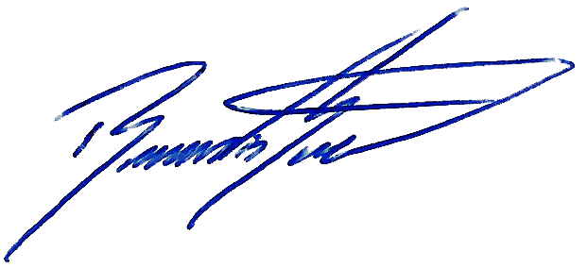

Signed:
Position: Managing Director
Date: 19/07/2025
Revision: 00

