- Introduction
Retrofit Compliance Services recognise and accepts its responsibility as set out in the Data Protection Act 2018, the EU General Data Protection Regulation and sub-legislation contained therein. The company, as a data controller and processor, will take all reasonable steps to meet this responsibility and to promote good practice in the handling and use of personal information. In particular, the company will comply with the data protection principles set out in the Data Protection Act 2018 and the EU General Data Protection Regulation.
This policy statement applies to all trustees and employees, and individuals about whom Retrofit Compliance Services process personal information, as well as other partners and companies with which the company undertakes it business.

- Scope
In order to conduct its business, Retrofit Compliance Services need to collect and use certain types of personal information about people with whom it deals in order to operate. These include current, past and prospective employees, suppliers, clients, and others with whom it communicates. In addition, it may be required by law to collect and use certain types of information to comply with the requirements of government departments. This personal information must be dealt with properly however it is collected, recorded and used – whether on paper, in a computer, or recorded on other material – and there are safeguards to ensure its compliance to the Data Protection Act 2018 and the EU General Data Protection Regulation.
We regard the lawful and correct treatment of personal information by Retrofit Compliance Services as very important in order to secure the successful carrying out of operations and the delivery of our services, and to maintaining confidence with those whom we deal. To this end we fully endorse and adhere to the principles of data protection, as enumerated in the Data Protection Act 2018 and the EU General Data Protection Regulation.

- Data Protection Principles
Specifically, the principles require that personal information:
- Processed lawfully, fairly and in a transparent manner in relation to individuals;
- Collected for specified, explicit and legitimate purposes and not further processed in a manner that is incompatible with those purposes; further processing for archiving purposes in the public interest, scientific or historical research purposes or statistical purposes shall not be considered to be incompatible with the initial purposes;
- Adequate, relevant and limited to what is necessary in relation to the purposes for which they are processed;
- Accurate and, where necessary, kept up to date; every reasonable step must be taken to ensure that personal data that are inaccurate, having regard to the purposes for which they are processed, are erased or rectified without delay;
- Kept in a form which permits identification of data subjects for no longer than is necessary for the purposes for which the personal data are processed;
- Processed in a manner that ensures appropriate security of the personal data, including protection against unauthorised or unlawful processing and against accidental loss, destruction or damage, using appropriate technical or organisational measures.
- Commitment
Retrofit Compliance Services will, through appropriate management and application of criteria and controls:
- Observe fully conditions regarding the fair collection and use of information;
- Meet its legal obligations to specify the purposes for which information is used;
- Collect and process appropriate information, and only to the extent that it is needed to fulfil operational needs or to comply with any legal requirements;
- Ensure the quality of information used, including its accuracy and relevancy for the purpose(s) specified;
- Apply strict checks to determine the length of time information is held;
- Ensure that the rights of people about whom information is held can be fully exercised. These include: the right to be informed that processing is being undertaken: the right of access to one's personal information; the right to prevent processing in certain circumstances; the right to correct, block or erase information which is regarded as erroneous);
- Take appropriate technical and organisational security measures to safeguard personal information;
- Ensure that personal information is not transferred abroad without suitable safeguards.

- Compliance
Furthermore, the company takes steps to ensure that:
- There is someone with specific responsibility for data protection in the organisation;
- Everyone managing and handling personal information understands that they are contractually responsible for following good data protection practice;
- Everyone managing and handling personal information is appropriately trained to do so and is appropriately supervised;
- Anybody wanting to make enquiries about handling personal information knows what to do;
- Queries about handling personal information are promptly and courteously dealt with;
- Methods of handling personal information are clearly described;
- Regular review and audit is made of the way personal information is managed;
- Methods of handling personal information are regularly assessed and evaluated;
- Methods and performance of handling personal information is regularly assessed and evaluated;
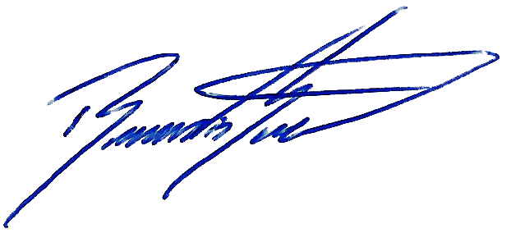
- It disseminates to employees, information on good practice in respect of handling, using and storing personal information.

Signed:
Position: Managing Director
Date: 19/07/2025
Revision: 00

