Purpose

Modern slavery is a criminal offence under the Modern Slavery Act 2015 (the “Act”). Modern slavery can occur in various forms, including servitude, forced or compulsory labour and human trafficking, all of which have in common the deprivation of a person’s liberty by another in order to exploit them for personal or commercial gain. This document sets out the policy of Retrofit Compliance Services (the “Company”) with the aim of the prevention of opportunities for modern slavery to occur within its businesses or supply chain. This policy’s use of the term “modern slavery” has the meaning given in the Act.

The Policy
  - We are also committed to ensuring there is transparency in our business and in our approach to tackling modern slavery throughout our supply chains, consistent with our disclosure obligations under the Modern Slavery Act 2015. We expect the same high standards from all of our sub-contractors, suppliers and other business partners, we include specific prohibitions against the use of forced, compulsory or trafficked labour, or anyone held in slavery or servitude, whether adults or children.
  - This policy applies to all persons working for us or on our behalf in any capacity, including employees at all levels, directors, sub-contractors, external consultants, third-party representatives and business partners.
  - Retrofit Compliance Services has overall responsibility for ensuring this policy complies with our legal and ethical obligations, and that all those under our control comply with it.

Communication and Awareness of this Policy
  - Training on this policy, and on the risk our business faces from modern slavery forms part of the induction process for all individuals who work for us.
  - Our zero-tolerance approach to modern slavery must be communicated to all suppliers, sub-contractors and business partners at the outset of our business relationship with them and reinforced as appropriate thereafter.

Compliance with the Policy
  - The prevention, detection, and reporting of modern slavery in any part of the business is the responsibility of all those working for us or under our control. Employees at all levels are required to avoid any activity that might lead to, or suggest, a breach of this policy.
  - You must notify your manager as soon as possible if you believe or suspect that a conflict with this policy has occurred or may occur in the future.
  - You are encouraged to raise concerns about any issue or suspicion of modern slavery in any parts of our business at the earliest possible stage.
  - If you are unsure about whether a particular act, the treatment of workers more generally, or their working conditions within any tier of our business constitutes any of the various forms of modern slavery, raise it with your manager.

  - We aim to encourage openness and will support anyone who raises genuine concerns in good faith under this policy, even if they turn out to be mistaken. We are committed to ensuring no one suffers any detrimental treatment as a result of reporting in good faith their suspicion that modern slavery of whatever form is or may be taking place in any part of our own business or in any of our supply chains. Detrimental treatment includes dismissal, disciplinary action, threats or other unfavourable treatment connected with raising a concern. If you believe that you have suffered any such treatment, you should inform your manager immediately.

Communication and Awareness of this Policy
  - Any employee who breaches this policy will face disciplinary action, which could result in dismissal for misconduct or gross misconduct.
  - We may terminate our relationship with other individuals and organisations working on our behalf if they breach this policy.
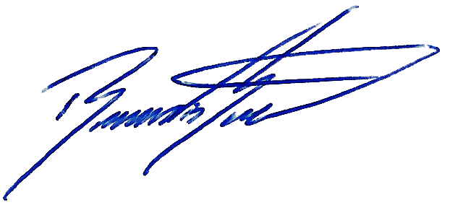

Signed:
Position: Managing Director
Date: 19/07/2025
Revision: 00

